ASSISTIVE TECHNOLOGY CATALOG – Updated 6/5/19 Images link to each individual item for more information.
Qty. |  | Vendor’s  Purchasing Info | Requirements | Description | Shelf
1 |  | ADAPTED MUSIC KIT: MINI CARILLON (with 6 10x7 tune cards)  Available from Enabling Devices (Item # 4063N or 2201, $449.95) | 4 C Batteries  4 A Batteries | These precision-tuned bells come with 6 color-coded song cards making it easy to play favorites like “Twinkle, Twinkle” and “Mary Had a Little Lamb” by pressing the color-corresponding switch. Musicians can also compose their own tunes or listen to 7 pre-recorded songs including “Old MacDonald” and “Row Your Boat.” Encourages listening and matching skills. | 3.1
1 |  | ADAPTED MUSIC KIT: MUSICAL SNAIL (with 6 tune cards)  Available from Enabling Devices (Item # 4063N or 1114, $189.95) | 2 AA Batteries | This teaching toy enables budding musicians to play musical notes by pressing its colorful buttons. Players can use color-coded cards (included) to play songs. Or, play 8 pre-recorded tunes by pressing the snail’s auto-play mode then activating its buttons. Improves listening skills and hand-eye coordination. | 3.1
1 | Not to be used with  seizure prone individuals. | ADAPTED MUSIC KIT: LIGHTED MUSICAL TAMBOURINE  Available from Enabling Devices (Item # 4063N or 896, $159.95) | 7 AA Batteries  Optional switch only activates lights…not LEDs, music, or vibration.  Can mount to tabletop with clamp (not included) | This instrument doubles as a capability switch. Swipe or gently push the tambourine to feel vibration, see multi-colored lights flash and hear music play. Lights, music and vibration can be turned on or off individually. Includes 1/8” to 1/8” male cord. | 3.1
1 | 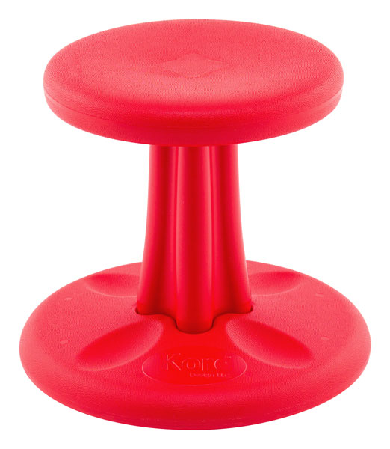 | 12”H KORE PRESCHOOL WOBBLE CHAIR (Red)  Available from Adaptive Mall (Item # 7011, $63.99 ea.) |  | Simple seat design to allow movement from side to side, front to back, or anywhere in between. The base is designed to allow movement in 360 degrees, but it's not too wobbly so it doesn't tip over. Another benefit is when you stand up, the chair stays in place. The FDA approved SMART PLASTIC Antimicrobial material helps protect your children against the spread of common bacteria. Capacity: 150 lbs. | 3.2
1 |  | ADAPTED MUSIC KIT: BAND JAM  Available from Enabling Devices (Item # 4063N or 1115, $367.95) | 8 C Batteries | Five-in-one battery-operated drum-set. Just press one of the five buttons on the toy’s base to hear sounds of a tambourine, triangle, drum, cymbal or maraca. Multicolored LED lights add to the sensory excitement. A great way to teach cause and effect and provide auditory stimulation. | 3.2
1 |  | PEA POD JR.  Available from Enabling Devices (Item # 3849, $89.95) |  | Pea Pod Junior provides a cocoon-like feel providing calm and deep pressure. Durable yet comfortable, it is made of inflatable heavy-gauge vinyl and covered with a soft, velvety surface. Surface washable. Fits most pre-K, kindergarten and first-grade students. Do not jump in or on the Pea Pod and keep sharp objects away. 48” L x 29” W x 20” H | 3.2
1 | 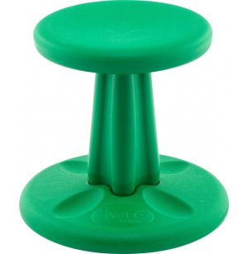 | 10”H KIDS KORE WOBBLE CHAIR  Available from Hertz Furniture (Item # KOR-590, $50.00) |  | Kore Wobble Chairs keep knees, hips and backs in comfortable positions. They are the perfect outlet for kids with excess energy, allowing them to focus, balance and stay in motion all while seated in a classroom. Capacity: 150 lbs. | 3.2
1 |  | ADAPTED MUSIC KIT: BONGO DRUMS (Adapted)  Available from Enabling Devices (Item # 4063N or 756, $169.95) | 2 Switch  4 C Batteries | These high-quality drums produce great sound, are made from animal hide, and can be tuned with an attached key. Activate two switches and enjoy hours of enjoyment while also improving auditory awareness and a receiving remarkable sensory satisfaction. Two 1/8” female jacks. | 3.3
1 |  | ADAPTED MUSIC KIT: DRUM  Available from Enabling Devices (Item # 4063N or 808, $116.95) | 2 C Batteries  Has built-in switch, can add a different switch. | Activate an external switch or press the yellow switch at the drum’s base and watch its drumstick twirl, creating a rapid succession of rhythmic beats. One 1/8” female jack. | 3.3
1 |  | ADAPTED MUSIC KIT: RING AROUND BELLS  Available from Enabling Devices (Item # 4063N or 2202, $249.95) | 4 C Batteries  Has built-in switch, can add a different switch. | Using the attached yellow switch, users make its colorful, precision-tuned bells twirl and play the musical scale while its multicolored LEDs blink. Or use a separate capability switch to activate a toy, twirl the toy’s beads by hand, or detach them from their stand to play them during music therapy or classroom music time. Ring Around Bells encourages listening, grasping and increases eye hand coordination. One 1/8” female jack. | 3.3
1 |  | ADAPTED MUSIC KIT: MUSIC MACHINE WITH INSTRUMENTS  Available from Enabling Devices (Item # 4063N or 703, $241.95) | Switch  8 A Batteries | Everything you need to start a fully inclusive band, this set includes cluster bells, castanets, jingle and drum sticks. Attach one of the musical instruments on to our striking musical stand, activate the switch and the machine beats to any preset rhythm at any speed you choose. One 1/8” female jack. | 3.3
1 |  | POSITIONING PILLOW: 18” WEDGE  Available from eSpecial Needs (Item # E08504, $113.95) |  | Positioning Pillows provide maximum comfort and support for your special needs child's physical therapy activities. Positioning Pillows contain a firm high-density urethane foam with vinyl sewn covering. Wedge dimensions: 18” x 24” x 6” | 3.4
1 |  | POSITIONING PILLOW: 32” WEDGE  Available from eSpecial Needs (Item # E08505, $152.95) |  | Positioning Pillows provide maximum comfort and support for your special needs child's physical therapy activities. Positioning Pillows contain a firm high-density urethane foam with vinyl sewn covering. Wedge dimensions: 32” x 20” x 12” | 3.4
1 |  | POSITIONING PILLOW: ROUND BOLSTER  Available from eSpecial Needs (Item # E08500, $64.95) |  | Positioning Pillows provide maximum comfort and support for your special needs child's physical therapy activities. Positioning Pillows contain a firm high-density urethane foam with vinyl sewn covering. Bolster dimensions: 24” & 6” diameter | 3.4
1 |  | WEIGHTED FLEECE VEST  (Large)  Available from Enabling Devices (Item # 3953L, $82.95)  Part of the Weighted Kit |  | A fantastic calming tool! A great looking weighted fleece vest is ideal for kids to keep warm, cozy, and secure. The vest is used to calm and to provide great sensory input. Inside pockets holds weights that can be easily changed. Includes 2 pounds of weights (two ½ pound weights and four ¼ weights). Large size fits ages 7-9. | 4.1
4 | 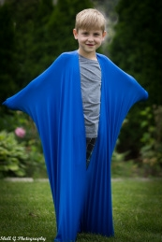 | COZY SENSORY BODY SACK  (2 small blue, 1 small red, 1 large blue available)  Available from Got-Special Kids (Item # 3890, $36.99 and $39.99) |  | Extra soft, stretchy lycra enfolds and comforts the user with calming pressure. Through resistance and balance, body sacks can help improve balance and body spatial awareness and can help make a child use their body more effectively. The sensory sack also offers deep pressure input which can help to calm a child and provide the ability to focus/concentrate better. The small sack is 27" x 40" and the large sack is 29” x 47” | 4.1
1 ea. size | 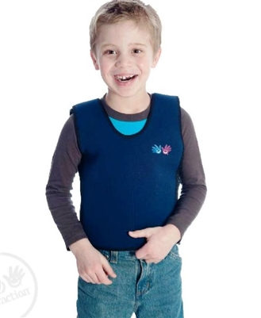  Note: Use weighted products with guidance from a therapist and adult supervision. | WEIGHTED COMPRESSION VESTS  (XXS with 2 half-pound weights, XS and Small with 4 half-pound weights each)  Available from Got-Special Kids (Item # 7011, $69.99 ea.) |  | Help kids calm down, focus and cope with sensory overload. The steady proprioceptive input and compression around the trunk are especially soothing for those with sensory challenges. Supports kids with ADHD, sensory integration disorder or autism. Weights are safely positioned in pockets inside the vest and can be added or removed. Your child may benefit from 20-30 minutes of wear each hour, or longer. Stretchy neoprene for a snug, comfy fit. Select a vest where the smallest width measurement is at least 4 inches less than the measurement around your chest. | 4.1
2 |  | WEIGHTED PUPPY  Available from Enabling Devices (Item # 3937, $46.95) |  | Wrap this soft weighted pup around your neck and shoulders to experience calming pressure that helps with self-regulation, attention and concentration. Microwavable and freezable for use as a hot or cold pack. 19” L x 4” W, 2 ¼ lbs. Unscented. | 4.1
1 | Note: Use with adult supervision. Never place in crib with infant; do not use with small children. Never cover face nor restrict child’s movement. | SOFT PLUSH WEIGHTED BLANKET (3 lbs., 30”x38”)  Available from Fun and Function (Item # CF6443, $99.99) |  | Soft and lightly weighted to provide calming proprioceptive input and grounding weight for kids with autism, ADHD and sensory integration disorder. For a calm-down break during the day, wrap around your child’s body, or roll them up like a burrito. Fold up the blanket to use as a lap pad during school work or at the table. Provides soothing tactile input and grounding weight | 4.1
1 |  | WEIGHTED COMPRESSION FIDGET BELT  (Small with 2 lbs. of weight)  Available from Fun and Function (Item # DR5901, $24.99) |  | Offers compression and weight to curb the wiggles and help calm children. Removable weights provide proprioceptive feedback for a grounding effect. Clip your favorite fidget onto the loop to engage fidgety fingers. Supports children with ADHD, sensory processing disorder or autism. Comes with 4 x 1.4 lb. weights and 2 x ½ lb. weights. Fits 25” to 29” hips. | 4.1
2 |  | GEL LAP PAD  Available from Enabling Devices (Item # 3142, $41.95), part of the Weighted Kit |  | Great for classroom use, this multipurpose pad, full of squishy, colorful sparkling gel, is a treat for the eyes, fingers and regulatory system. Improves user’s focus, concentration and ability to self-soothe. Wipes clean. 10"L x 18"W. Weighs 5 lbs. | 4.1
2 |  | MEDIUM-WEIGHTED BLANKET/BODY SHAWL (5 lbs., 28”x20”)  Available from Enabling Devices (Item # 3941, $77.95), part of the Weighted Kit |  | Cozy and comforting, our weighted blankets enhance sensory integration, improve concentration and attention. Filled with non-toxic pellets and hand washable. Box stitching keeps pellets in place, so weight is evenly distributed. Medium blanket size: 28″L x 20″W. Weight: 5 lbs. | 4.1
2 | 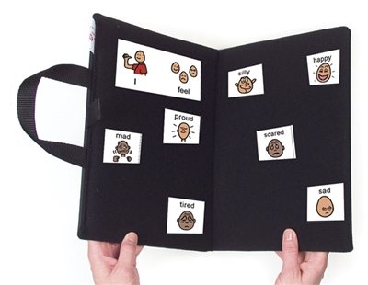 | PORTABLE BI-FOLD COMMUNICATION FOLDER  Available from Augmentative Resources (Item # 032037, $38.80) |  | Communication board to carry with you wherever you go! Inside of folder made of VELTEX® Brand Loop Display Fabric. Outside made of waterproof nylon fabric. Place “hook” side of Hook & Loop on back of pictures to use for communication/choice-making. Equipped with handle and Hook & Loop closure. Open size 18” x 24”; Closed 9” x 12” | 4.1
2 | 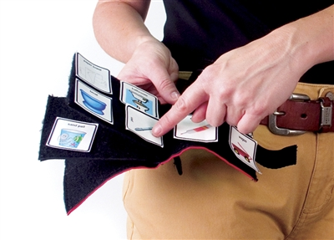 | PORTABLE COMMUNICATION BOOK WITH FABRIC PAGES  Available from Augmentative Resources (Item # 0321017, $23.16) |  | A picture communication choice book you can take anywhere! Attaches to belt/loop with webbing strap. Held onto Belt or loop by strong webbing and snap. Webbing is held to book by Hook & Loop, making book easy to attach/detach during use. Holds a total of Twenty Four 2" X 2" Pictures (Four per page). Kept closed by Hook & Loop for simple open/close. | 4.1
2 | 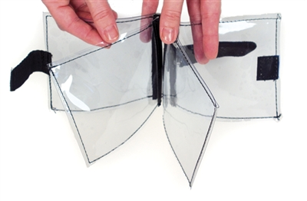 | PORTABLE COMMUNICATION BOOK WITH CLEAR PAGES  Available from Augmentative Resources (Item # 032026, $24.60) |  | Simply slip pictures/words into the pockets and point to communicate. Made of durable, washable, clear vinyl (plastic). Both front and back of pages are usable. Hooks on belt with Hook & Loop Closure. Six 4” x 4” pages, with pockets. Held closed with Hook & Loop Closure | 4.1
2 | 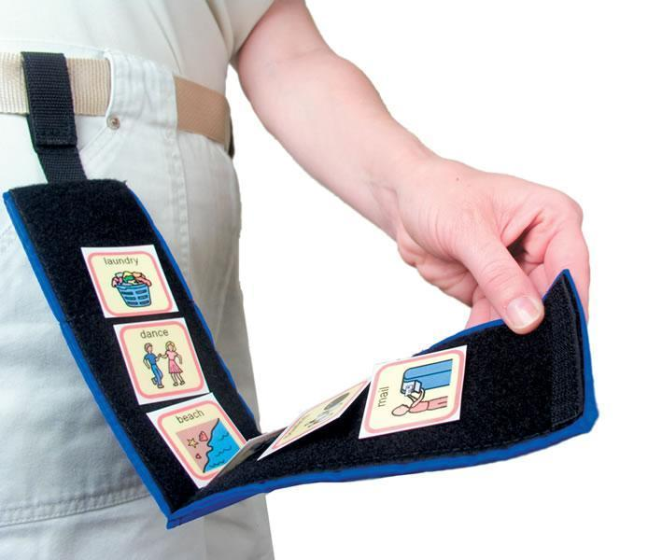 | PORTABLE FABRIC BI-FOLD SCHEDULE  Available from Augmentative Resources (Item # 031017, $22.91) |  | Attaches to belt/loop with webbing strap. Hook & Loop closure for easy opening/closing. Lined with VELTEX® Brand Fabric on inside, which the Hook side of Hook & Loop will adhere. Outside cover made of durable nylon. “Finish” pocket in top of schedule. Height is 8 1/2“ in closed position. Bifold accommodates eight 2”x2” pictures. | 4.1
2 packs of 3 | 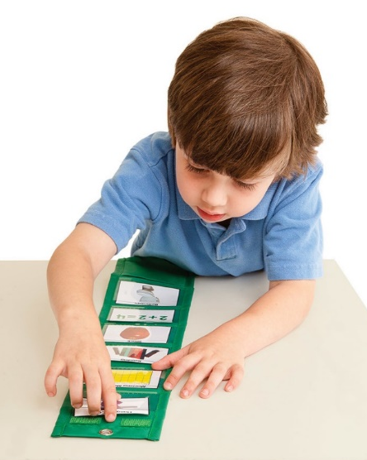 | PORTABLE VISUAL SCHEDULE POCKET CHART  Available from Carson Delossa (Item # 858001, $17.99) |  | This pocket chart features six clear vinyl pockets, 4 1/4" x 2" each, to help organize a student's schedule for both home and school. Unfolded chart is 21” long. Also includes a fabric storage pocket, 4 1/4" X 4", where students can put their task cards after completing each task. Each pack includes three portable visual schedules. Free schedule cards are available for download on the products web page. | 4.1
1 | 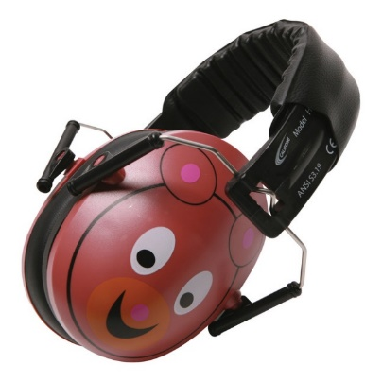 | CALIFONE HUSH BUDDY BEAR EARMUFF HEARING PROTECTOR  Available from School Specialty (Item # 1543886, $16.34) |  | The Hush Buddy Bear is designed for children who need increased quiet for sensitivity reasons or for more focused activities such as reading. Earmuff has cushioned ear pads and an industry leading Noise Reduction Rating of 27dB. The wide padded headband equally distributes weight, providing superior comfort, even when worn for long periods of time. | 4.1
1 | 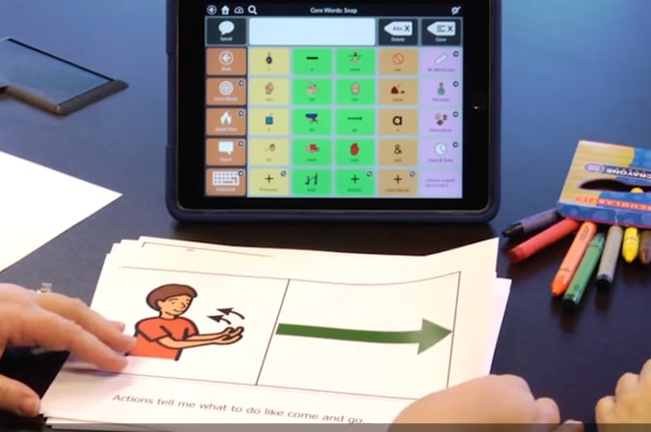  For more information: https://www.tobiidynavox.com/en-US/software/windows-software/boardmaker/ | BOARDMAKER STUDIO FOR WINDOWS  Available from Tobii Dynavox, $399.00)  Other versions are available including Boardmaker Online. | All English versions of Boardmaker are currently 6.1.6. CD/DVD drive required. | Easy-to-use features let you design your own materials with symbols supported in dozens of languages. Select your own topics, labels, colors, borders and more. Have access to more than 30,000 Picture Communication Symbols (PCS®). Also includes features designed to save you valuable time, like hundreds of Studio Starter Templates and an easy to understand interface, so you can spend less time creating materials and more time with your students. | 4.1
3 |  | PRINT IT! ICON MAKER  Available from Enabling Devices (Item # 4069, $39.95)  One in each communication kit |  | This inexpensive Icon Maker enables users to print their own icons. Compatible with Cheap Talks, Choice 4, Go! Boards, Jumbo Switches, Put-Em-Arounds, Talkables, and Twin Talk which are all in the RTC Assistive Technology library as well as other devices. Comes with up to 300 color icons, usage instructions and icon templates. PDF Format is compatible with PCs and MACs. | 4.1
1 |  | BRIGHT SWITCH FOR THE VISUALLY IMPAIRED  Available from Enabling Devices (Item # 2045, $124.95), part of the Kit for the Visually Impaired | 2 AA Batteries | A great choice for visually impaired users, this switch’s bright blinking light makes it easy to locate. When the switch is activated, its textured yellow light shines, music plays and the switch vibrates. Set device to enable any or all stimuli, and to turn blinker on and off. Includes double-ended 1/8” male jack cord. 7"D x 3¾"H, 1 lb. | 4.2
1 |  | DOME ALONE  Available from Enabling Devices (Item # 69, $125.95), part of the Kit for the Visually Impaired | 4 C Batteries | Our bestselling dome toy enchants users with its dancing, colorful confetti, music and lights. Sold with or without a built-in switch, the dome encourages reaching and improves listening skills and visual attention. Both versions have on/off switches and volume control. 1/8” jack. 11"L x 10"W x 6"H, 2½ lbs | 4.2
1 |  | VIBRATING LIGHT  Available from Enabling Devices (Item # 458, $104.95), part of the Kit for the Visually Impaired | 4 AA Batteries | Our best-selling vibrating light is even more captivating now that it comes with a bright LED light. Press the textured plate and enjoy visual, auditory and tactile sensations. Available with or without music, both versions can be used as a switch to activate adapted devices, placed on a lapboard or mounted on a wall (mounting hardware included). Includes 1/8” double ended male jack cord. 9"L x 2"H x 12"W, 1¼ lbs. | 4.2
1 |  | MUSICAL LIGHT BOX  Available from Enabling Devices (Item # 200, $89.95), part of the Kit for the Visually Impaired | 2 C Batteries | This multi-purpose musical light box can be used as a bright backlight for tracing or as a light source for people with visual impairments. Increases visual attention and is great for working on pre-writing and writing skills. Easily activated by any of our capability switches. Has 1/8” jack for use with capability switches. 12" x 11" x 4", 1 lb. | 4.2
1 |  | VISUALLY IMPAIRED ACTIVITY CENTER  Available from Enabling Devices (Item # 520, $189.95), part of the Kit for the Visually Impaired | 2 C Batteries | Specially designed for those with visual impairment, this multisensory activity center features a bright blue tactile plate that vibrates when touched, a pull-ball that activates a fan and a textured bright yellow oval plate that turns on an AM/FM radio. 13½"L x 9"W x 4½"H, 1¾ lbs. | 4.2
1 | Choking hazard. Small parts. Not for children under 3 years. | PENGUIN ROLLER COASTER  Available from Enabling Devices (Item # 300, $47.95), part of the Kit for the Visually Impaired | 1 D Battery  Switch | Adorable little penguins climb to the top of their iceberg and “swoosh” down the slide to the bottom. Increases visual attention and tracking skills. Works with your capability switch. | 4.2
1 |  | TOTALLY TACTILE COMMUNICATOR  Available from Enabling Devices (Item # 2046, $295.95), part of the Kit for the Visually Impaired | 4 AA Batteries | Designed especially for the visually impaired user, this communicator features brightly colored plates with raised designs and adjustable activation time (1-12 seconds) to give users time to recognize and activate their message. Features 6 levels for a total of 36 messages and a total record time of 300 seconds, 7 seconds per message. Comes mounted on a Lazy Susan. 14½"L x 14½"W x 3"H, 4 lbs. | 4.2
1 | 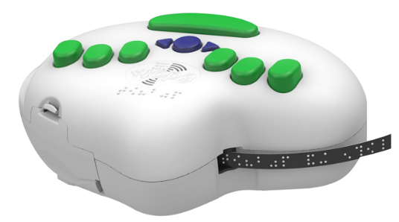 | PROXTALKER 6DOT BRAILLE LABEL MAKER  Includes embossing tape, adapter and Qwerty keyboard with USB adapter.  Available from RehabMart (Item # 39521, $767.26) | 4 AA Batteries | Powerful but simple, the 6dot's ergonomic design makes it portable and user-friendly. Embosses Braille in any language into adhesive labeling tape. Works with light touch for users with limited hand strength. Built in Braille keyboard or USB port allows you to plug in a QWERTY keyboard for an alternative typing method. | 4.2
2 | 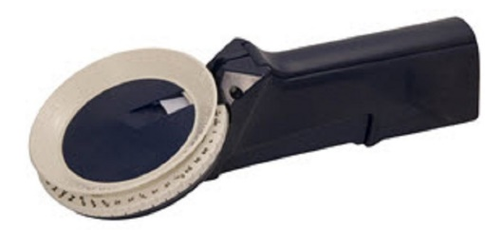 | PORTABLE BRAILLE LABEL MAKER  Available from RehabMart (Item # 30381, $55.84) | CHECK OUT WILL INCLUDE EMBOSSING TAPE | This easy to use, lightweight and portable Braille labeler has a tactile dial that has both print letters and Braille letters for the complete alphabet, numbers, commonly used contractions, and punctuation. | 4.2
1 set | 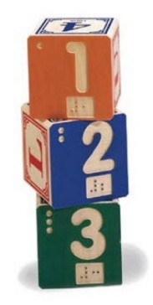 | WOODEN BRAILLE BUILDING BLOCKS: NUMBERS  Available from RehabMart (Item # 29580, $43.82) |  | Braille Blocks are a perfect cognitive toy to help teach children about both Braille and sign language. The carved detailing on the blocks lets a blind or sighted child feel his or her way along the letters or numbers, and the bright colors stand out. | 4.2
1 set | 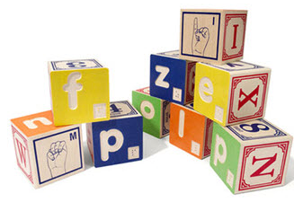 | WOODEN BRAILLE BUILDING BLOCKS: ALPHABET  Available from RehabMart (Item # 29580, $65.89) |  | Braille Blocks are a perfect cognitive toy to help teach children about both Braille and sign language. The carved detailing on the blocks lets a blind or sighted child feel his or her way along the letters or numbers, and the bright colors stand out. | 4.2
1 | 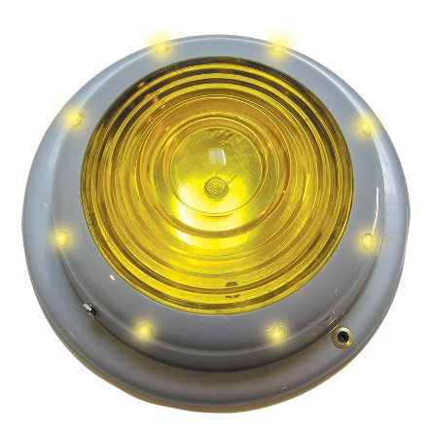 | TAIL LIGHT SWITCH –  SAY-IT-PLAY-IT  Available from Enabling Devices (Item # 464, $143.95), part of the Kit for the Visually Impaired | 4 AA Batteries | All it takes is a gentle touch to activate this switch that plays a 20-second long message as it lights up and vibrates. Particularly well-suited for the visually impaired, the Tail light Switch can also be used to turn on toys and devices. 7¾"D x 2½"H | 4.2
1 | 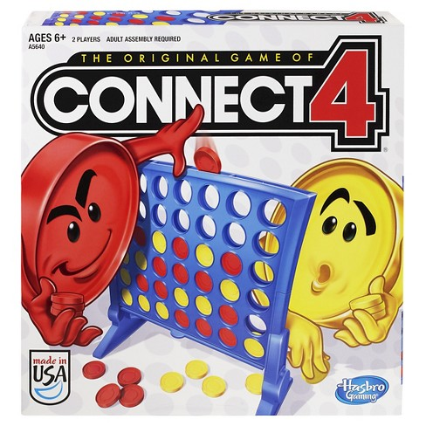  Choking hazard. Small parts. Not for children under the age of 3. | CONNECT 4 GAME  Part of the Kit for the Visually Impaired from Enabling Devices. |  | Be the first player to get four of your color discs in a row. On your turn, drop a disc into any slot until one player gets four of their color discs in a row—horizontally, vertically, or diagonally. Red pieces are tactilely adapted for impaired vision children. Suitable for children over 6. | 4.2
1 | 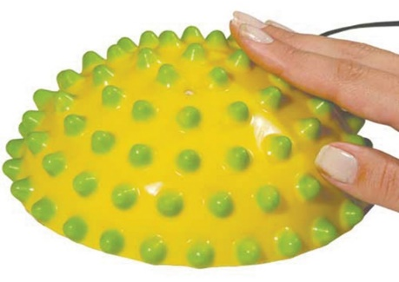 | SENSO DOT VIBRATING SWITCH  Available from Enabling Devices (Item # 682, $86.95), part of the Kit for the Visually Impaired | 2 AAA Batteries | Our tactile and visually stimulating switch provides a wonderful somatosensory experience when activating any toy or device. The slightest push on any part of the dome will activate a toy while you feel a soft vibration. The colorful tops can easily be turned around and around. 6"D x 2¾"H. | 4.2
2 | WARNING:  Contains natural rubber latex. | KOOSH SWITCH  Available from Enabling Devices (Item # 883, $98.95), part of the Kit for the Visually Impaired | 2 AA Batteries  Lights and music are disabled when using a switch. | Everyone will love our unique Koosh Switch! Use it as a toy and be rewarded with lights, music and vibration. When used as a switch, users can enjoy vibration and that irresistible koosh texture. 8½"L x 5¼"W x 2½"H, 1 lb. | 4.2
1 |  | CHOICE 4 COMMUNICATOR  Available from Enabling Devices (Item # 1237, $311.95), part of the Kit for the Visually Impaired | 4 AA Batteries  Objects, icons, headphones not included. | This terrific transitional communicator has 12 levels, 300 seconds of recording time and enables users to illuminate objects, photographs or icons sequentially with its brilliant lights. Work with 1, 2, 3 or 4 fields depending on users’ skills level. Also features direct select or single switch scanning with auditory cueing, adjustable scanning speeds of 2, 6 or 9 seconds, 3 broadcast options—speaker, headphones or speaker and headphones. Three snap-in-place covers included to cover “Off” fields. Can download PDF template for icons from Enabling Devices. 8"L x 15½"W x 3"H, 2¼ lbs. | 4.3
1 |  | 4 CHOICE SEQUENTIAL SCANNER FOR THE VISUALLY IMPAIRED  Available from Enabling Devices (Item # 1247, $399.95), part of the Kit for the Visually Impaired | 2 C and 4 AA Batteries  Switch  Can also check out an articulated arm that expands from 14” to 24” and clamp fitted for both tubular and flat surfaces. | This state-of-the-art communicator illuminates icons so they are easier to see. Equipped with 12 levels, four fields and 300 seconds total recording time, this unique device provides 4 modes of scanning – Inverse, Automatic, Two Switch and Step—adjustable scanning speed (1-12 seconds), on/off auditory cueing, volume control, four icon holders, a storage compartment in its base, and a carrying handle. Communicator Size: 16"L x 2½"W x 6"H; Base Size: 17"L x 5¾"W x 4"H. Weight: 4¾ lbs. | 4.3
1 |  | 4”x5” VISUALLY IMPAIRED COMMUNICATOR  Available from Enabling Devices (Item # 7083, $399.95)  Part of the Kit for the Visually Impaired | 4 C and 4 AA Batteries  Icons not included. | Specially designed for the visually impaired, this state-of-the-art communicator has 12 levels, 4 modes of adjustable scanning capabilities and large brightly illuminated targets that make it possible to see, select and activate messages. To activate, simply press on the selected icon or picture. The target will light up and play up to a 300 second pre-recorded message. Also features recordable level announcer; two jacks for one or two switch scanning; two switches with lights; on/off auditory cueing; and headphone capability. | 4.3
1 |  | TACTILE SYMBOL COMMUNICATOR  Available from Enabling Devices (Item # 4040, $429.95)  Part of the Kit for the Visually Impaired | 4 AA Batteries | Uniquely designed for those who are blind or dually sensory impaired, this six-level communicator with room for 36 six-second messages, uses tactile symbols for concrete or abstract representations that can be tactually recognized by the user. Touch one of the six removable symbols to activate a message and feel an (optional) vibration. Includes six tactile symbols—Bathroom; Something wrong; Drink; I want; Finished; Eat—to get started communicating right away. 14"L x 10½"W x 2"H, 3½ lbs. | 4.3
1 |  | EYE TALK BUNDLE  Available from Enabling Devices (Item # 3711, $135.95) |  | The Eye Talk eye gaze communication board paired with a mountable Clip Clamp. Easily mounts to any wheelchair tray, tabletop or bedrail. Attach messages to the board, observe the user’s eye gaze and receive your message. | 5.1
1 |  | VISUAL SPEECH TRAINER  Available from Enabling Devices (Item # 9153, $129.95) | 4 AA Batteries | Learning to form words properly comes more naturally when speech therapy clients can practice while looking in this communicator’s attached mirror. Simply touch the device’s plate switch to activate messages and begin visual speech training. The communicator accommodates four 5-second messages and can also be externally activated by plugging a switch into its jack. | 5.1
2 |  | READING TIME COMMUNICATOR  Available from Enabling Devices (Item # 1524, $235.95) | 4 AA Batteries | Clip any size book onto the device, record each page of text using the 6 built-in mini-gumball switches; place a colored sticker on each page of the book that corresponds to the colors of the switches. To hear the story, press the switch that matches the colored sticker on that page. Removable stickers are included. Features six 25-second messages on four levels; true voice recording quality; level changer and volume control. | 5.1
5 |  | STAY PUTS  No longer available for purchase from Enabling Devices. |  | Stay Puts hold just about any object – toys, utensils, writing implements, etc. – and keep them from dropping on the floor. Objects are easily retrievable and stay clean. Two strong suction cups hold the Stay Put in place on your wheelchair tray, table, desk, or bed tray. Three chains each equipped with a key ring allow you to easily attach most items. Three Velcro cable ties are also included. | 5.1
1 | Note: Removable brush head should be sanitized before use. | SKIN MASSAGER  Available from Enabling Devices (Item # 3123, $51.95)  Part of the boxed Autism Spectrum Disorder Kit | 1 AA Battery | Provide sensory stimulation or relaxation with this soft vibrating brush. Designed with a tactile, easy-grip handle, this massager comes with its own screwdriver so users can adjust its vibration to the intensity they prefer. 4.5" x 3" x 2". Weighs ¼ lb. | 5.1
1 |  | SOMATOSENSORY TUBES  Available from Enabling Devices (Item # 402, $106.95)  Part of the boxed Autism Spectrum Disorder Kit | 2 AA Batteries | Instant rewards! Perfect for developing grasping skills, localizing sound and teaching cause and effect. Simply pick up the tube, hold it in a vertical position and it instantly rewards you with glowing lights, music and soothing vibrations. 12" x 2.5”. Weighs ¾ lb. | 5.1
2 |  | TALKING PHOTO ALBUM  Available from Enabling Devices (Item # 9127, $62.95)  Part of the boxed Autism Spectrum Disorder Kit and the Classroom Communication Kit | 3 AAA Batteries | A wonderful way to facilitate communication and express creativity, this interactive communicator encourages users to tell their stories through photos, icons and drawings. Just press the bottom of each page (with moderate pressure) to play a 10 second message that describes the image pictured. Contains 20 pages and holds 5×7 photos. | 5.1
1 |  | TIME TRACKER  Available from Enabling Devices (Item # 1301, $59.95)  Part of the boxed Autism Spectrum Disorder Kit | 4 AA Batteries | A terrific way to set time limits, enforce time-outs, ease transitions and teach time management skills. This innovative timer has three lighted levels—green, yellow and red— that signal users to the passing of time by flashing sequentially and (if desired) sounding an auditory cue. 3.5" x 9". Weighs 1.25 lbs. | 5.1
1 | 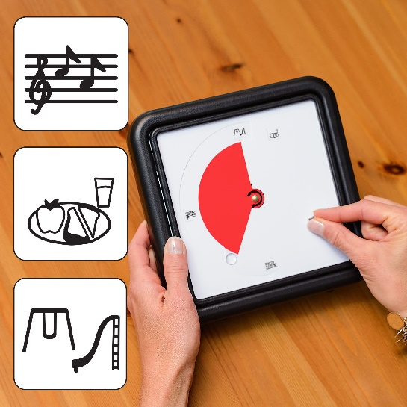 | TIME TIMER VISUAL TIMER – 8” MAGNET WITH VISUAL SCHEDULE KIT  Available from timetimer.com  (Timer = $39.45, Visual Schedule Kit = $15.95) | 1 AA Battery | Ideal 60-minute timer for small to medium groups. Not only can it adhere to a markerboard or metallic material, but it can also stand alone or hang on the wall. It’s simple: when the red is gone, time is up – making life’s routines easy and productive! The Visual Schedule Kit is ideal for younger children or any person who benefits from the ability to view pictures of activities instead of numbers. Kit includes 2 blank faces and 2 sheets of activity stickers (reading, wash hands, school bus, etc.) | 5.1
1 |  | REGULATION CUBES  Available from Fun and Function (Item # MW6316, $37.99) |  | Regulation cubes are like Simon Says dice to encourage sensory motor planning. Toss up the Regulation Cube and see what lands. Each colorful side suggests a different gross or motor activity. Great for solo or group play. Includes 2 cubes and 24 colorful illustrated cards. 6” vinyl square. Each cube weighs 5 oz. Surface wash. Air dry. | 5.1
1 |  | LIGHTED VIBRATING MIRROR  Available from Enabling Devices (Item # 358-M, $149.95)  Part of the Classroom Communication Kit | 6 AA Batteries | Perfect for circle time, this extraordinary mirror lights up and vibrates when users pick it up. Encourages visual attention and bi-lateral hand usage. Vibration intensity is adjustable. 8½" x 12", 1¾ lbs. | 5.1
10 ea. | 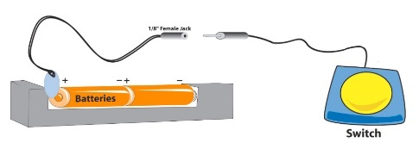 | BATTERY INTERRUPTER: (Available for AA, C, and D batteries)  Available from Enabling Devices (Item # 686, $209.95) |  | Unadapted? No problem. This easy-to-install interrupter enables you to make a switch adapted toy or device for use with any of our switches. Many battery-operated toys can be adapted to run with an adaptive switch by using a battery interrupter. These battery-operated devices must have an on/off switch. | 5.1
3 | 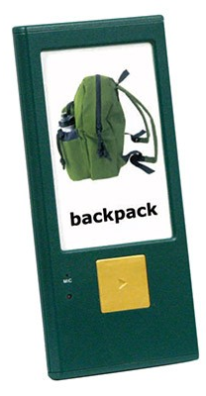 | GOTALK ONE  Available from eSpecial Needs (Item # E00973, $14.95) | 2 button batteries (AG13) included | An inexpensive, high-quality single message talker with a large picture display and a big, colorful PLAY button! Super slim and light, weighing less than 2 oz. Put your picture display into the covered frame and slide the switch on the back to record. Press the play button and talk for up to 10 seconds. When you’re done recording, slide the switch to play. Approx 5" x 2.5" x 0.375" | 5.1
3 | 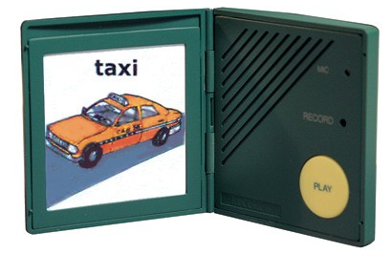 | PERSONAL TALKER  Available from eSpecial Needs (Item # E16612, $13.95) | 4 button batteries (AG13) included | The Personal Talker is a great introduction to AAC or can be used for spoken reminders. Record a message and then push the large PLAY button to play back the message. A picture symbol or written information can be inserted in adjoining frame. Has ten seconds recording time, enough time several sentences. A pen point is needed to record, eliminating accidental erasure/record over. If pushing the PLAY button is too difficult, begin teaching single switch access by attaching a self-adhesive “bumper” (included). Place a picture symbol on front cover, then simply press on the cover to activate the message. Keeps messages even if battery dies. 2.5" square by 0.5" | 5.1
1 |  | IPAD WIRELESS ONE SWITCH  Available from Enabling Devices (Item # 1164, $199.95) |  | Control hundreds of switch-friendly apps on a Bluetooth-equipped electronic device. Features a large target area for easy activation; accepts one of your own capability switches; works through Bluetooth 2.1 for simple pairing; has a range of over 50 feet; and acts as a regular capability switch for other switch-adapted products. Comes with a standard switch cable and USB charging cable. 80-100 hours of use per charge. 5″Diameter. Weight: ¾ lb. | 5.2
1 |  | IPAD WIRELESS TWO SWITCH  Available from Enabling Devices (Item # 1167, $205.95) | Wall charger | Control hundreds of switch-friendly apps on a Bluetooth-equipped electronic device. This essential two switch features large target areas for easy activation; accepts one or two of your own capability switches; has six modes for additional functions; works through Bluetooth 2.1 for simple pairing; has a range of over 50 feet; and acts as a regular capability switch for other switch-adapted products. Comes with a standard switch cable and USB charging cable. 80-100 hours of use per charge. 5″W x 12½”L x 1¾”H. Weight: ½ lb. | 5.2
1 |  | PULL AND PLAY SWITCH  Available from Enabling Devices (Item # 8042, $99.95) |  | Activate devices while practicing reaching, swiping and grasping skills. This innovative switch comes with two interchangeable grips—a 4” ball with holes and a 3” T grip—and can be mounted to a tabletop, wheelchair tray or bedrail. C-Clamp is included. | 5.2
1 | NOTE: Straws should be sterilized before use. | GRIP & PUFF SWITCH  Available from Enabling Devices (Item # 700, $99.95)  Part of the boxed Switch Assessment Kit | Anti-contamination filters (item 977) and extra straws (item 960-S) are available from Enabling Devices. | Perfect for those with severe mobility challenges, this pneumatic switch is activated by a gentle squeeze of its vinyl grip or by puffing on its mouth tube. | 5.2
1 set |  | GRIP SWITCH KIT (Grips only add versatility to Grip and Puff Switches)  Available from Enabling Devices (Item # 701, $53.95)  Part of the boxed Switch Assessment Kit |  | These brightly-colored tubular grips are easily interchanged with our Grip and Puff switches. Each kit comes with five grips approximately 4″ in length and in varying diameters from ½” to 1″. The larger the grip, the easier it is to activate. | 5.2
2 |  | ULTIMATE SWITCH (With 19” Gooseneck)  Available from Enabling Devices (Item # 1671, $149.95)  Part of the boxed Switch Assessment Kit |  | Designed for use by even the most profoundly physically or neurologically challenged individuals. Super-versatile, multifunctional, durable enough to withstand heavy use, yet sensitive enough to respond to even the slightest touch. The included clamp allows for tabletop, tray or wheelchair use and features an adapter for horizontal alignment. The switch only requires 10 grams of force (the weight of a paper clip) and ¾” movement to activate. | 5.2
1 |  | JUMBO SWITCH (Red)  Available from Enabling Devices (Item # 787R, $60.95)  Part of the boxed Switch Assessment Kit |  | Jumbo Switches have large surface areas that are perfect for people with limited target ability. Comes with two free plastic covers—one with a lip and one without—and a removable mounting plate. 5” D x 1” H | 5.2
1 |  | ADJUSTABLE ANGLED SWITCH  Available from Enabling Devices (Item # 1032, $99.95)  Part of the boxed Switch Assessment Kit | C-Clamp not included (#2025) | Extremely accessible, this 5-inch, colorful switch can be adjusted from a 32 to 90-degree angle to accommodate the unique needs of every individual. Easy to mount on tabletops with a clamp. | 5.2
1 |  | BRIGHT RED SWITCH  Available from Enabling Devices (Item # 262, $89.95)  Part of the boxed Switch Assessment Kit | 2 AA Batteries | Its large target area and bright red color make this a great choice for those who are visually impaired. Simple to operate, this versatile switch lights up and vibrates when pressed, and will also activate an adapted toy or device. 5” D x 2 ¼” H, ¾ lb. | 5.2
1 |  | MOVEMENT SENSOR SWITCH  Available from Enabling Devices (Item # 655, $95.95) | 1 9V Battery | This sensor switch picks up even the tiniest movements, enabling activation by people with even the most severe physical challenges. Provides momentary, on/off or timed output from one to 120 seconds. Includes double-ended 1/8” male jack cord. | 5.2B
2 |  | SOUND ACTIVATED SWITCH  Available from Enabling Devices (Item # 1051, $99.95) | 1 9V Battery | Perfect for people with very limited mobility, this ultra-sensitive switch can be activated with a clap or a whisper. Choose between three modes: in timed mode, adjust the switch to remain on for 1-120 seconds post-activation; in on/off mode, one sound turns on the device and another sound turns it off; in momentary mode, the device is activated for the duration of sound detection. The switch can also be adjusted for sound sensitivity. Includes double-ended 1/8” jack cord. | 5.2B
1 |  | TILT SWITCH  Available from Enabling Devices (Item # 990, $42.95)  Part of the boxed Switch Assessment Kit |  | Perfect for users who can’t activate a switch manually, this gravity-sensitive switch has a Velcro strap that attaches to a head, arm or leg and is activated when the user tilts that body part. Extremely versatile, this switch can be adjusted for tilt sensitivity and is also a great tool for posture training. | 5.2B
2 |  | GUMBALL SWITCH (Yellow)  Available from Enabling Devices (Item # 782Y, $53.95)  Part of the boxed Switch Assessment Kit |  | Recognized for their high quality and dependability, these best-selling switches feature a 2½” activation surface. Provides extraordinary tactile and audible feedback. Removable base has three holes for easy mounting. Comes with two plastic covers – one with a lip, one without. | 5.2B
2 |  | MINI-GUMBALL SWITCH (Blue)  Available from Enabling Devices (Item # 787B, $51.95)  Part of the boxed Switch Assessment Kit |  | A smaller version of our best-selling Gumball Switches, the “minis” share the same incomparable tactile and auditory feedback, versatility and durability as their big siblings, but their smaller size means they can be mounted almost anywhere. Their bases have three holes for easy mounting and a removable mounting plate. 2” D x ½” H, 1 oz. | 5.2B
1 |  | PINCH SWITCH  Available from Enabling Devices (Item # 800, $37.95)  Part of the boxed Switch Assessment Kit |  | Small enough to be held in the hand of a child, this simple, sensitive switch activates toys and devices with the gentlest pressure. The perfect way to teach grasping, fine motor and prehension skills. | 5.2B
1 |  | THUMB SWITCH  Available from Enabling Devices (Item # 802, $35.95)  Part of the boxed Switch Assessment Kit |  | Capitalizes on thumb mobility! Grip the yellow cylindrical base in your hand and press the red button with your thumb for momentary switch operation. | 5.2B
2 |  | BUTTON CLICK SWITCH  Available from Enabling Devices (Item # 775, $40.95)  Part of the boxed Switch Assessment Kit |  | Sometimes simple is best. This reliable little switch provides momentary output with merely 40 grams of pressure! 2 ½” W x 2 1/2” L, ¼ lb. | 5.2B
2 |  | FINGER ISOLATION BUTTON  Available from Enabling Devices (Item # 716, $54.95)  Part of the boxed Switch Assessment Kit |  | The recessed button on this uniquely designed switch encourages practice of fine motor and finger isolation skills needed for mastery of computers and touch screen devices. 3” D x 1 ½” H, 3 oz. | 5.2B
1 |  | PETITE PILLOW SWITCH (Green)  Available from Enabling Devices (Item # 831, $59.95)  Part of the boxed Switch Assessment Kit |  | Soft and pliable, encased in foam, and covered with a removable, washable bag, this unique switch makes a great choice for users with limited head and limb movements. 3” D x 2” H, 3 oz. | 5.2B
1 |  | SWITCH MODIFIER  Available from Enabling Devices (Item # 605, $79.95)  Part of the boxed Switch Assessment Kit | 1 9V Battery | A wise choice for those with uncontrolled movements or tremors, this ingenious device transforms any momentary switch into an on/off or timed one. Our new intention adjustment feature requires users to press the switch for 1-15 seconds before the device is triggered. Once intention time is set, choose between momentary, on/off or timed modes. In the momentary mode, your toy or device will stay on as long as you maintain pressure on the switch. In the on/off mode, your device will turn on when the switch is pressed once and will turn off when the switch is pressed again. In timed mode, your toy or device will stay on for a preset amount of time (1-120 seconds). Includes double-ended 1/8” male jack cord. | 5.2B
1 | 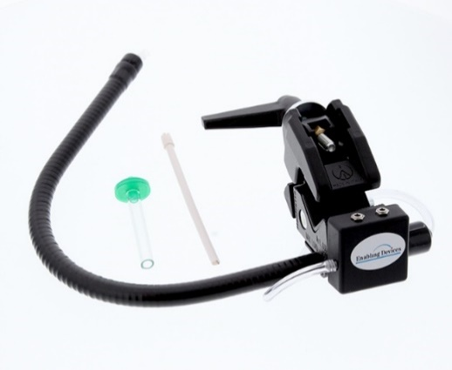 | SIP AND PUFF SWITCH (Double Closure)  Available from Enabling Devices (Item # 970, $187.95)  Part of the boxed Switch Assessment Kit | Straws should be purchased or sanitized before use.  Additional filters are item 977 and come in a set of 6 for $40.95.  Additional straws are item 960-S and come in a set of 20 for $20.95. | Perfect for patients with severe physical impairments! Control two devices with one switch. Just sip on the tube to activate one device then puff on it to activate the other. Mounted (adaptable to tubular or flat surfaces) on a 19” gooseneck with a 3-way mounting clamp, the Sip and Puff is easy to access. The control module is attached with Velcro for versatility. Comes with an anti-contamination filter, a connector to attach to the gooseneck, a bendable mouth straw and two 1/8” double ended male jack cords. | 5.2
1 | 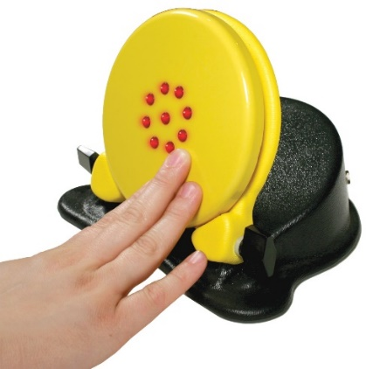 | ADJUSTABLE ANGLE SEQUENCER WITH SWITCH  Available from Enabling Devices (Item # 806, $198.95) | 4 AA Batteries  C-Clamp not included (#2025) | Designed especially for visually impaired users, this sequencing communicator has 300 seconds of recording time and a built-in switch that’s easy to locate due to its large size and the circle of LED lights at its center. The sequencer’s angle can be adjusted from 32 to 90 degrees, its light can be turned on and off and it can be clamped or unclamped according to user’s preferences. Also acts as an external switch for other devices. 8"L x 8"W x 6¼"H | 5.2
2 | 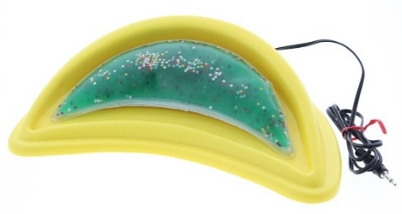 | GOOSHY SWITCH  (With green pillow or blue pillow)  Available from Enabling Devices (Item #636, $125.95) | 2 AA Batteries | This soft, squishy, sparkly pillow comes with lights, vibration, and music — enabling users to reap any or all rewards with the touch of a switch. 10"L x 4½"W x 2"H, weighs 1 lb. | 5.2
1 | 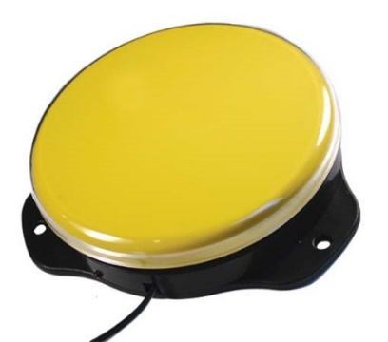 | ON/OFF JUMBO SWITCH  Available from Enabling Devices (Item #7805, $65.95) |  | Our bright yellow Jumbo Switch is easy to use and just right for people unable to sustain hand pressure over time. Simply press the switch once to turn on your device and press it again to turn it off. Comes with a plastic cover. | 5.2B
1 | 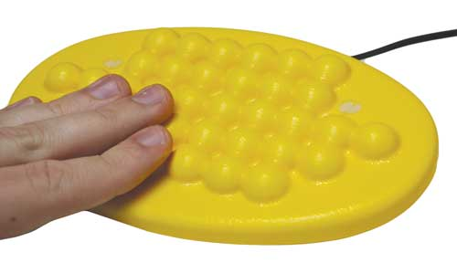 | SUPER BUMPY SWITCH  Available from Enabling Devices (Item #736, $50.95) |  | The right choice for those who crave tactile stimulation, this bright yellow switch will activate all your toys and devices. 8"L x 4½"W x ½"H, weighs: ¼ lb. | 5.2B
1 | 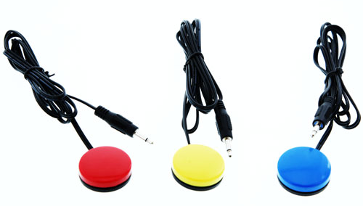 | COMPACT SWITCH (Set of 3)  Available from Enabling Devices (Item #745, $66.95) |  | These pocket-size switches are sensitive, affordable and can be mounted to almost any surface (Velcro included). Use all three to activate three devices at once. ¾"D x ¾"H. | 5.2B
1 |  | SMALL SEQUENCER WITH LEVELS  Available from Enabling Devices (Item # 8152, $183.95)  Part of the Quick Start Communication Kit | 4 AAA Batteries | We added 4 levels to our bestselling compact communicator in addition to its single, sequential, and random message capabilities! Features 4 levels, 300 seconds of recording time, sequential capability for storytelling, random capability for games or cards, can be activated by an external switch, and has an output jack for activating other devices. 6 ¼”L x 6 ¼”W x 3”H | 5.3
1 |  | WRIST TALKER  Available from Enabling Devices (Item # 3037, $59.95) | Watch Battery | As easy to wear as a watch, this basic communicator records one 10-second greeting. Superior sound quality, simple recording and an adjustable strap make this a reliable option. Strap is adjustable. 2 ¼” D x 1 ½” H | 5.3
1 |  | TUBULAR VIBRATOR (Adapted)  Available from Enabling Devices (Item # 1151, $70.95) | 4 AA Batteries | Flexible 2-speed vibrator that can be wrapped around almost any body part to provide soothing and energizing vibrotactile feedback. | 5.3
12 |  | PUT -EM-AROUNDS  Available from Enabling Devices (Item # 9020B, $399.95)  Part of the boxed Autism Spectrum Disorder Kit (5) and the Classroom Communication Kit (5) and the Quick Start Communication Kit (2) | 4 AA Batteries | Users can be part of the conversation wherever they are with these wall communicators. Just mount the compact devices in strategic locations in the classroom and enable users to play pre-recorded 20-second messages throughout the day. Mounting hardware included. Can be mounted on lap boards or tabletops. 8" x 6.5”. Weighs 1 lb. | 5.3
2 |  | BIG TALK TRIPLE PLAY SEQUENCER  Available from Enabling Devices (Item # 2392, $184.95)  Item no longer available. See Item 1391 | 4 AA Batteries | This versatile communicator provides single, sequential and random message capabilities, includes four levels and 75 seconds per level for 300 seconds of recording time. Use it for cards, games, storytelling and more. Can be activated by an external switch or used to activate other devices. Can program witch messages activates your devices. 7”D x 4 ½” H. | 5.3
3 |  | MINI-COM SEQUENCER  Available from Enabling Devices (Item # 9151-S, $129.95)  Part of the Classroom Communication Kit and the Quick Start Communication Kit | 4 AA Batteries | Terrific for story-telling, singing and joke-telling, this small-scale, attachable communicator features 300 seconds of recording time and includes an icon, picture or word holder. 5½"L x 6"W x 3"H, 1/2 lb. | 5.3
2 |  | TALKABLE III  (With built-in icon holder)  Available from Enabling Devices (Item # 2401, $151.95)  Part of the Classroom Communication Kit and the Quick Start Communication Kit | 4 AA Batteries | Easy communication! Compact and intuitive, these basic easy talk message communicators come with built-in icon holders and free clear covers. 15 seconds total record time; records three messages; three output jacks for simultaneous output. The Talkable III size: 10½”L x 5″W x 2¾”H. Weight: 1 lb. | 5.3
2 |  | TWIN TALK  Available from Enabling Devices (Item # 1405, $129.95)  Part of the Classroom Communication Kit and the Quick Start Communication Kit | 4 AA Batteries | Perfect for those new to communication technology, the Twin Talk teaches skills needed to progress to more complex devices. Equipped to record, play back and re-record two 10-second messages. Lets you make requests and simple selections, sing songs, produce sound effects and play games! 13"L x 6½"W x 2"H | 5.3
2 |  | 7-MESSAGE TAKE OR PLACE N’ TALK GO BOARD  Available from Enabling Devices (Item # 3356, $229.95)  Part of the boxed Autism Spectrum Disorder Kit and the Classroom Communication Kit | 4 AA Batteries | Actively engage users in their daily schedule with this effective picture and talking scheduler. It’s designed with easy to access recording controls and seven 3”x 3” icon holders. It records and plays seven 35-second messages that are activated each time icons are removed or replaced from their frames. The pocket on the front of the unit can be used for storage. Wall mounting hardware is included. Icons not included. 29.5"L x 5.25"W x 3"H. Weighs 2.25 lbs. | 5.4
2 |  | 7-LEVEL COMMUNICATION BUILDER  Available from Enabling Devices (Item # 7075B, $369.95)  Part of the boxed Autism Spectrum Disorder Kit and the Classroom Communication Kit | 4 AA Batteries | This progressive communication builder grows along with your child. Start with one message, then advance to using two messages, then four messages, and so on. As communication skills develop, move up to our 16-window grid. This seven-level communicator offers the capacity to record up to 112 messages with a total recording time of 300 seconds. Re-recording is required when you change window frames. Frame size is 8½” x 7″. 2.5 lbs. Icons not included. | 5.4
1 |  | TIC TAC TOE  (Adapted)  Available from Enabling Devices (Item # 949, $176.95)  Part of the boxed Autism Spectrum Disorder Kit and the Kit for the Visually Impaired | 4 AA Batteries | An adapted version of the classic toy! Get “tic tac toe” by activating a switch that lights up LED squares in a horizontal, vertical or diagonal direction. The winner is rewarded with music and flashing lights! Teaches turn-taking, directionality and placement skills. Has two switch inputs so players can use their own capability switches. 11" x 13.5" x 9.5". Weighs 2.25 lbs. | 5.4
1 |  | GO! BOARD  (With 8 icon holders)  Available from Enabling Devices (Item # 3338, $75.95)  Part of the Classroom Communication Kit |  | Lunch-time? Circle time? Nap time? Help students stay on schedule with space for eight picture symbols. Once the student completes a scheduled activity or task, the icon is removed from the board, and can be placed in a pocket at the base of the board. Comes with a set of 2”x 2” icon holders. NOT A TALKING DEVICE. 29"L x 5½"W x 3"H | 5.4
1 |  | CHEAP TALK 8  Available from Enabling Devices (Item # 4202R, $346.95)  Part of the Classroom Communication Kit | 4 AA Batteries  Icons not included. | Provides space to record and re-record 48 five-second messages on six levels. Ideal for building language skills and encouraging communication. Four jack inputs allow external switches that correspond to four of the message plates. 12½"L x 8"W x 3"H | 5.4
2 | 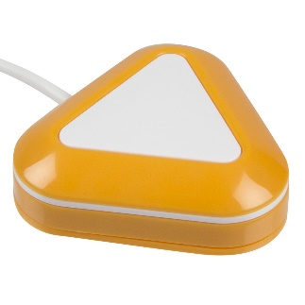 | LITTLE CANDY CORN PROXIMITY SENSOR SWITCH  Available from AbleNet (Item # 10000005, $195.00) | Battery included  (Replaceable CR2032 battery available from Amazon) | Highly sensitive switch that does not require a physical touch from the user to activate. Simply wave a hand or move your body within 1/2-inch of the Candy Corn to activate. Visual and auditory cues occur when the switch is activated. 1.9-inch-wide activation area. Internal magnet for mounting or option to attach to your surface with screws (not included). Attached 1/8” switch jack. | 6.1
2 | Note, in high humidity or temperatures below 23 Fahrenheit/-5 Celsius, BIG Candy Corn may not work as intended and could lock in an always activated state or not activate at all. For high humidity scenarios, turn BIG Candy Corn off for 10-minutes to allow it to adapt to the surrounding climate. In extreme cold scenarios, BIG Candy Corn will need to be turned off until it can be used in a warmer setting. | BIG CANDY CORN PROXIMITY SENSOR SWITCH  Available from AbleNet (Item # 10000025, $215.00)  (Replaceable CR2430 battery available from Amazon) | Battery included | Highly sensitive, almost twice the size of the Little Candy Corn switch and does not require a physical touch from the user to activate. Simply wave a hand or move your body within 1-in. of the switch or activate with a light touch. An auditory beep and visual feedback can be turned on and off. Includes replaceable CR2430 battery that will last approximately 150,000 activations. Internal magnet for mounting or use the two threaded inserts to mount with the AbleNet Universal Mounting Plate (sold separately). Attached 1/8” jack cord. | 6.1
2 | Note: Not waterproof, but it does have an extra layer of protection to help prevent damage caused by moderate amounts of moisture. | TALKTRAC WEARABLE COMMUNICATOR  Available from AbleNet (Item # 10002000, $145.00) | Integrated Rechargeable Battery | Features 4 messages and 2 levels for a total of 8 individual messages. A perfect companion for those on the Autism spectrum, helping them feel more comfortable in social situations by helping them converse with family and friends, interact with classmates, and record to-do lists. Two volume levels. Include blank overlays. Weighs 2.1 ounces with battery. Overlays are Boardmaker compatible or template downloadable from Ablenetinc.com. | 6.1
2 |  | LITTLE STEP-BY-STEP CHOICE WITH LEVELS  Available from AbleNet (Item # 10003600, $195.00) | Standard Alkaline 9V Battery | By pressing the activation surface repeatedly, you can skip over multiple messages to get to your desired message. When you find the message you are looking for, release the activation surface and the message will play in its entirety. This is a great tool for answering multiple-choice questions or communicating desires among a list of options. Includes red, yellow, blue and green switch tops. Attach your switch of choice into the 1/8” input jack. Has a clear cap for picture symbol use. Base removes for easy mounting. | 6.1
2 |  | LITTLE STEP-BY-STEP WITH LEVELS  Available from AbleNet (Item # 10002600, $195.00) | Standard Alkaline 9V Battery | Levels are ideal for pre-recorded sequential messages. With a total of four minutes of recording time, there is no limit to the number of messages per level. Includes red, yellow, blue and green switch tops. Attach your switch of choice into the 1/8” input jack. Has a clear cap for picture symbol use. Base removes for easy mounting. | 6.1
2 |  | LITTLE STEP-BY-STEP GAMEPLAY  Available from AbleNet (Item # 10003900, $195.00) | Standard Alkaline 9V Battery | Simply record your messages into the device and activate the surface to play the message. What makes Step-by-Step GamePlay unique are its three levels:  Level 1: Randomization - Randomizes your message selections.  Level 2: Random Elimination - Randomizes the selections and once a selection is played, it is eliminated.  Level 3: Choice - Allows a user to skip through a series of messages to get to the desired message by activating the surface multiple times in a row. Switch tops include red, yellow, blue and green. Attach your switch of choice into the 1/8” input jack. Has a clear cap for picture symbol use. Base removes for easy mounting. | 6.1
2 |  | LITTLEmack  Available from AbleNet (Item # 10002400, $135.00) | Standard Alkaline 9V Battery | This single message dedicated speech generating device enables you to record one message up to 2-minutes long directly to the device. For message playback, activate the angled 2.5-in. switch top or use an alternative switch for access. Perfect for mounting and is recommended for persons who can access a smaller target area. Volume control, on/off switch. Includes red, yellow, blue and green switch tops. Attach your switch of choice into the 1/8” input jack. Has a clear cap for picture use. Base removes for easy mounting. | 6.1
2 |  | BIGmack  Available from AbleNet (Item # 10002100, $135.00) | Standard Alkaline 9V Battery | Record any single message up to two minutes in length directly into the communicator and press its activation surface for playback. Connect a toy or appliance for additional motivation. Large 5-in. activation surface. Volume control, on/off switch. Includes red, yellow, blue and green switch tops. Mounting plate not included but can be temporarily mounted with screws. Includes 1/8” jack cord. Attach your switch of choice into the 1/8” input jack. Has a clear cap for picture symbol use. | 6.1
2 Sets of 3 |  | TALKING BRIX  Available from AbleNet (Item # 10003400, $145.00) | Integrated Rechargeable Battery | Thin, lightweight communicators with built-in magnets perfect for carrying in a pocket or placing around the room. Use for personal reminders or attach as many as you like to create simple, scalable communication grids. Straight-line layouts reinforce sequential communication or linear learning activities. L-shape and other layouts allow users to create communication grids that meet their unique physical needs. Sold in packs of three with a recording time of 10-seconds each. Weighs 1.5 ounces. One each of red, blue and green. Each Brix includes a clear snap cap for use with picture symbols. | 6.1
2 |  | JELLY BEAN TWIST  Available from AbleNet (Item # 10033400, $65.00) | Requires 4 AA Batteries | Features a 2.5-in. activation surface and is recommended for users who can access a smaller target area. Switch tops can be removed and replaced with the color of your choice: Red, Blue, Yellow, or Green. Also includes a clear snap cap for symbol use. 6-foot cord. | 6.1
2 | 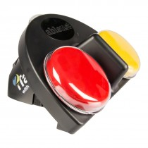 | iTALK2 WITH LEVELS  Available from AbleNet (Item # 10003300, $190.00) | Standard Alkaline 9V Battery | Record two messages with this dedicated speech generating device and then play back by activating the two 2.5-in/6.4-cm switch tops. Includes 4-minutes of record time, three recording levels, and supports the use of two external switches for alternative methods of access. Includes a built-in symbol holder at the top of the device for 2x2 pictures or symbols. Has two 1/8” jack cords and two clear covers for use with picture symbols. (Does not include the removable mounting base.) | 6.1
2 |  | SUPER TALKER PROGRESSIVE COMMUNICATOR  Available from AbleNet (Item # 10002800, $375.00) | Requires 4 AA Batteries | Use it as a single message communicator for beginners and progress to 2, 4, or 8 messages as the user's needs and abilities change with no need to learn a new device. Features 16-minutes of recording time and a total of eight levels of messaging capability so you can store as many as 64-messages; built-in keyguard storage, volume control with lockout feature; and two 1/8” switch input cords. Compatible with Matrix Maker or Boardmaker software or download blank overlays from ablenetinc.com. Control of toys/appliances requires PowerLink 3, but a step-ahead jack input accommodates a capability switch. | 6.1
2 |  | QUICKTALKER 7  Available from AbleNet (Item # 10000005, $165.00) | Requires 4 AA Batteries | A portable dedicated speech generating device that features 7-message locations and 6-minutes of record time. Simply switching between the five available recording levels provides up to 23-messages. Includes built-in carrying handle. Includes a paper grid to attach icons to and a plastic cover for insertion into the grid. | 6.2
2 |  | QUICKTALKER 12  Available from AbleNet (Item # 10003502, $185.00) | Requires 4 AA Batteries | A portable dedicated speech generating device that features 12-message locations and 12-minutes of record time. Simply switching between the five available recording levels provides up to 48-messages. Includes built-in carrying handle. Includes a paper grid to attach icons to and a plastic cover for insertion into the grid. | 6.2
2 |  | QUICKTALKER 23  Available from AbleNet (Item # 10003503, $205.00) | Requires 4 AA Batteries | A portable dedicated speech generating device that features 23-message locations and 20-minutes of record time. Simply switching between the five available recording levels provides up to 103-messages. Includes built-in carrying handle. Includes a paper grid to attach icons to and a plastic cover for insertion into the grid. | 6.2
1 ea. | 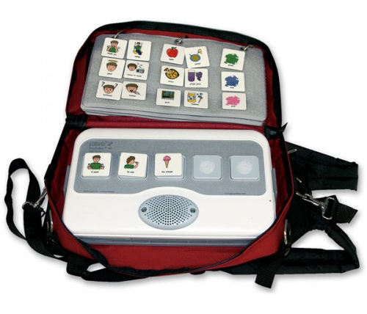 | LOGAN PROXTALKER (Available with a Female or Male voice)  Available from Enabling Devices (Item # 4087 or 4088, $2995.95) | 4 C Batteries | This advanced speech generating device uses RFID (radio frequency identification) technology which enables independent verbal picture communication for non-verbal people. Simply place any photo or symbol on a sound tag card, place the card on one of the five buttons, and push to hear the recorded message. Includes 80 pre-recorded sound tags, 100 blank sound tags, carry case, and 2 sets of programming tags. | 6.2
2 | 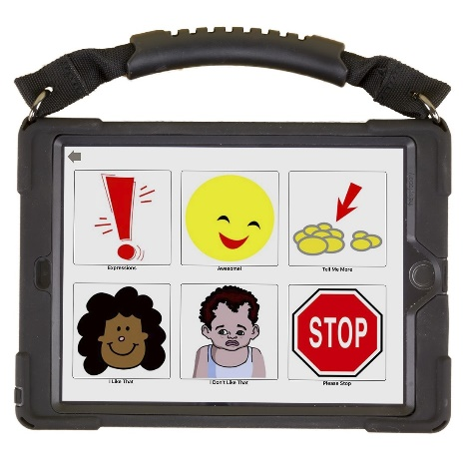 | QUICKTALKER FREESTYLE MINI (With Prologuo2Go and Crescendo)  Available from AbleNet (Item # 70000119, $3495)  2 year warranty  Comes with the iPad mini, an amplified speaker, Blue2 Bluetooth access switch, and protective case |  | The device provides unique flexibility by harnessing the power of the iPad mini’s 7.9-inch dynamic multi-touch display. This unit is a flexible, dynamic display speech generating device (SGD) pre-installed with Proloquo2Go, an AAC (Augmentative and Alternative Communication) app designed to support all users, from beginning to advanced. Also features Crescendo™, a complete research-based core word vocabulary with 10,000+ fringe words which also supports bilingual use. More than 25,000 symbols and 100 natural-sounding free voices across all languages, including children’s voices. Add your own buttons and photos. Visit the Assistiveware.com website for more information. | 6.2
1 | 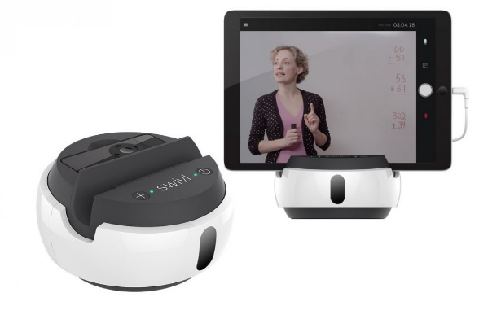 | SWIVL C SERIES ROBOT  (With 4 markers, and adjustable height floor stand)  (Includes case, charger, 3x adapter grips, Micro USB to Lightning cable, Micro USB to Micro USB, and manual.  Available from swivl.com  Item SW3322-C3, $799 Additional markers can be purchased  $99 for the stand | Requires Swivl app to be installed on mobile device and open to operate.  Accepts any mobile device or device with case under 12mm thick. (Not included) | Swivl is a robotic platform that allows the user to plug in a tablet, a smartphone or a DSLR for easier recording of a class lecture, presentations, and even action sports. Swivl is the first and only iPod, iPhone, iPad mini, and iPad Air accessory that lets teachers and students capture hands-free video, following their every move and recording their every word with a wireless microphone.  HOW IT WORKS  Capture: Upload videos captured with the Swivl app or add your own. Use the Swivl Robot and/or Expand Lens for added benefits!  Review: Leave private time-stamped notes for your own reference. Add time-stamped annotations before sharing videos.  Dialogue: Securely share videos and engage in transformative dialogue with public or private time-stamped comments. | 6.2
1 |  | FUZZY FRIENDS & SWITCHES: PRETTY KITTEN  Available from Enabling Devices (Item # 4064 or 904, $43.95) | Switch  2 AA Batteries | Pretty Kitten meows as it moves back and forth when you activate your switch. | 6.3
1 |  | FUZZY FRIENDS & SWITCHES: FLOPPY BUNNY  Available from Enabling Devices (Item # 4064 or 150, $42.95) | Switch  2 AA Batteries | Floppy Bunny hops and wiggles its nose when you activate your capability switch. This switch adapted plush toy is great for teaching cause and effect. | 6.3
1 |  | FUZZY FRIENDS & SWITCHES: SHELLY SEAHORSE  Available from Enabling Devices (Item # 4064 or 4084, $29.95) | Switch  3 AAA Batteries | Soothing to the senses! Activate your capability switch and Shelly Seahorse plays uplifting calypso music while her belly glows with ever-changing colors. | 6.3
1 |  | FUZZY FRIENDS & SWITCHES: BAA BAA BABY  No longer available. | 3 AAA Batteries | Activate your switch and this cute baby lamb toddles along bleating while shaking its head and wagging its tail. | 6.3
1 |  | TRANQUIL TURTLE  Available from Enabling Devices (Item # 4083, $52.95) | 3 AA Batteries | Evoking a magical underwater effect, this fuzzy friend is a calming influence on everyone he meets! His aquamarine color, wave-like motions and soothing sounds simulate the peaceful mood inspired by an ocean breeze. Adjustable settings for brightness, movement and volumes provide the opportunity for an individualized sensory experience. | 6.3
1 |  | FUZZY FRIENDS & SWITCHES: BABY PUG  Available from Enabling Devices (Item # 4064 or 1174, $42.95) | Switch  3 AAA Batteries | Just activate your capability switch and this pup walks, nods its head and makes realistic sounds. Great for teaching cause and effect and for developing tracking as well as sensory fun. | 6.3
1 |  | SOUND PILLOW WITH VIBRATION  Available from Enabling Devices (Item # 3140, $69.95) | Switch  2 D Batteries  3 AAA Batteries | We’ve switch adapted this vibrating pillow that gives slumbering users sound choices of music, water, white noise and a heartbeat. Simply remove the sound machine from the pillow’s interior, choose the preferred sound and attach the switch. Pillow can be turned on and off and has two vibration speeds. Covered with a soft corduroy fabric. Sound machine has a 15-minute auto timer shut off. | 6.3
1 |  | WRAP AROUND MASSAGER (Unadapted)  Available from Enabling Devices (Item # 1163, $61.95) | 2 C Batteries | Our flexible 2-speed tube massager provides vibro-tactile feedback whenever and wherever it’s needed. Wrap it around any part of the body and a convenient hook closure holds it in place. 49" x 1.75". Weighs 1.75 lbs. | 6.3
1 each of 5 |  | SOUND PUZZLES  Available from Enabling Devices (Item # 9036, $242.95) | 2 AAA Batteries | Few toys offer more opportunities for interactive learning than our colorful wooden sound puzzles. Now designed with knobs for grasping and an angled base for viewing, the set of 5 different puzzles teach about shapes and colors, and the sounds of farm and zoo animals, transportation vehicles and musical instruments. | 6.3
1 |  | PETITE HOWDAHUG ADJUSTABLE SEAT  Available from Fun and Function (Item # VS2502, $79.99) |  | Provide wiggle room and comfortable boundaries. A zippered compartment holds an inflatable wiggle cushion. Place on chair or floor. Use with adult supervision. Ideal for kids with ADHD, sensory processing disorder or autism. | 7.1
1 | 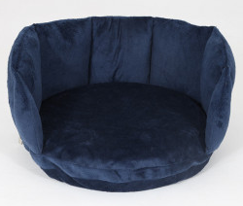 | BOUNDARY WIGGLE SEAT  Available from Fun and Function (Item # CF6816, $64.99) |  | Provide wiggle room and comfortable boundaries. A zippered compartment holds an inflatable wiggle cushion. Place on chair or floor. Use with adult supervision. Ideal for kids with ADHD, sensory processing disorder or autism. | 7.1
1 | 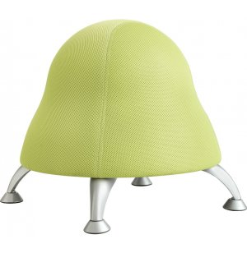 | RUNTZ PRESCHOOL BALL CHAIR  Available from Hertz Furniture (Item # SFC-475, sour apple, $147.00) |  | Runtz Chairs let little ones channel their enthusiasm and move around. Anti-burst PVC exercise balls provide a lasting bounce that won’t diminish over time. When this chair needs an extra bit of air just use the pump (included) to fill it back up and your chair will be as good as new. Double mesh polyester fabric upholstery. 22.5” diameter. 17” seat height. Weighs 14 lbs. Weight Capacity is 250 lbs. | Not in Cabinet
1 | 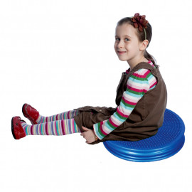 | MY MAGICAL CUSHION  Available from Fun and Function (Item # BA1884, $26.99) |  | Trouble sitting still? This air-filled seat cushion stimulates sensory awareness to help moderate the wiggles. Comes inflated! Challenges balance reactions, engages core and encourages proper seated posture. By moving around on the cushion, kids not only stay in their spot but can also benefit from better focus. Also works great as a booster seat during school work or while eating at the table. Encourages weight shifting and movement to sharpen focus. Supports challenges of ADHD, sensory processing disorder and autism. Challenges balance and offers postural training. Can be used with the Boundary Wiggle Seat. | 7.1
1 | 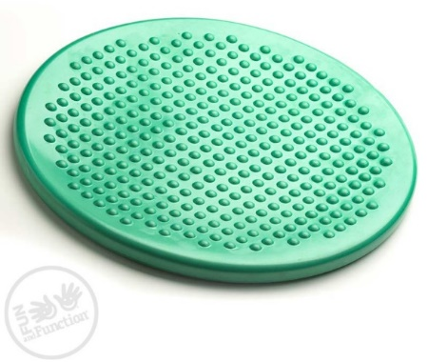 | MY MAGICAL CUSHION (Green)  Available from Fun and Function (Item # BA1884, $29.99) |  | Less obtrusive than a therapy ball, but just as helpful for curbing the wiggles! The Wiggle Cushion travels easily from home to school for an instant seat that encourages active learning. Provides a constructive outlet for movement during circle time, desk work or while eating. Smooth surface on one side. Other side has slightly raised bumps for extra tactile support. Encourages weight shifting and movement to sharpen focus. Supports challenges of ADHD, sensory processing disorder and autism. Challenges balance and offers postural training. Inflate by mouth, with straw or with needle pump. | 7.1
1 | 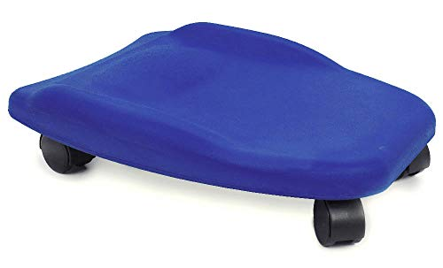 | SOFT TUMMY SCOOTER (Blue)  Available from Fun and Function (Item # MW5690, $56.99) |  | Made of soft-cell foam with a large tapered seat to support sitting, kneeling and prone positions. Supports upper and lower body, improving balance, posture, core strength and coordination. Ideal for children with sensory processing challenges, low tone, ADHD and autism. Made for play, vestibular therapy and motor planning activities. Use in prone, sitting or kneeling positions for vestibular therapy. 17.5”L x 14”W x 2.5”H (tapered width from 14” to 6.5”). Supports 150 lbs. | 7.1
1 ea. | 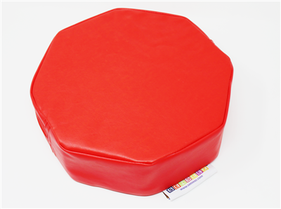  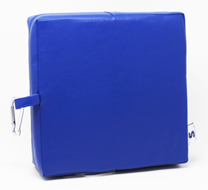 | SENSEEZ VIBRATING PILLOW  (Red Octagon and Blue Square are available)  Available from Got-Special Kids (Item # 3222, $23.78) | 2 AA Batteries | While they’re great for any kids with energy, the Senseez sensory cushions make ideal special needs cushions, especially for children with autism, ADHD, or sensory processing disorder. The vibrating cushions can calm kids who need more sensory feedback or help train hypersensitive kids to tolerate more sensations. The vinyl material makes them easy to keep clean! The pillows are small enough to take anywhere! 10" x 10" x 3” | 7.1
1 | 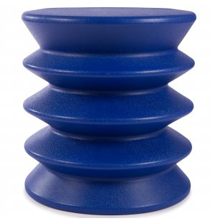 | KIDSERGO ACTIVE SEATING STOOL  Available from Hertz Furniture (Item # ERE-4000, blue, $75.00) |  | Active seating design encourages constant movement which strengthens core muscles, supports the natural curve of the spine, stretches the legs, and maintains a healthy blood flow. Adapts to suit the user. When you sit on the chair, it compresses slightly to the height of standard seating, so you can use it with any standard-size work surface. Made from recyclable UV-stable technopolymer for use both indoors and outdoors. 14” diameter, 15” seat height. 4.5 lbs. Weight capacity of 170 lbs. | 4.4
1 | 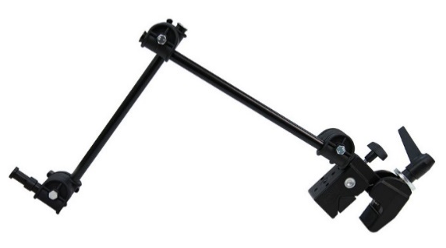 | LIGHT DUTY MAGIC ARM SYSTEM  (14” to 24” articulation arm and c-clamp)  Available from Enabling Devices (Item # 1557, $166.99 ea.) |  | This ergonomically designed, flexible system has a single articulated extendable arm (14”L – 24”L) with two sections and a heavy-duty clamp. Mounts securely to any wheelchair, table or bedrail and holds up to 3.3 pounds. Clamp (#1559) can also be purchased without the arm. Two mounting plates (#1569) available separately. 2 ¼ lbs. | 7.2
1 | 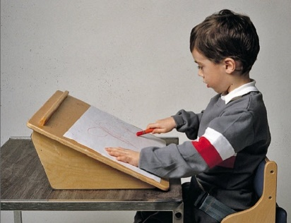 | THERADAPT PORTABLE FLIP TOP EASEL  Available from RehabMart (Item # 17444, starting at $174.88) |  | This lightweight easel can be turned one of two ways for different types of work. large enough to provide both children and adults with room to work, yet still easily portable, with a skid-resistant base. Book edge keeps objects from falling off. 45-degree side and 30 degree side allow for versatile use. 18” W x 16” D | 7.3
1 | 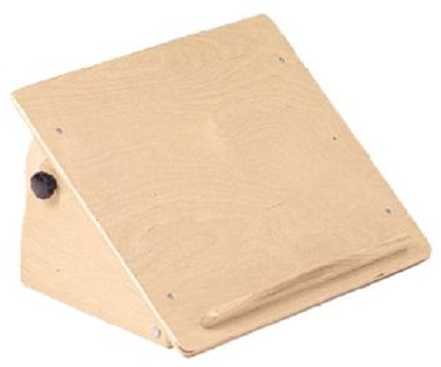 | THERADAPT ADJUSTABLE ANGLE EASEL  Available from RehabMart (Item # 17440, starting at $219.51) |  | Recommended for visually challenged individuals and other users who may need close proximity to reading and writing materials. Work surface can be set at any angle between 40 and 70 degrees. Promotes an erect head and trunk and encourages optimal eye gaze. Book edge prevents objects from sliding off. Skid resistant bottom keeps the easel from moving forward during use. 18” W x 16” D | 7.3
1 | 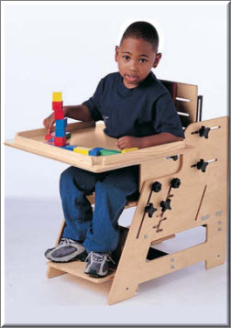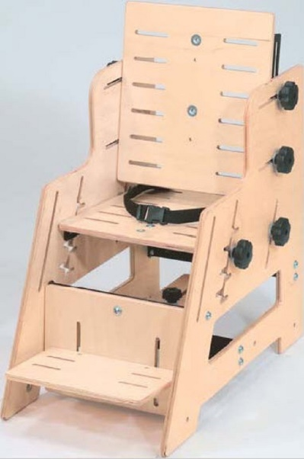 | THERADAPT TRANSITION CHAIR  (Early Childhood Size)  Available from RehabMart (Item # 17224, starting at $763.45) |  | The TherAdapt Transition Chair can be adjusted to fit the changing needs of one child, or the different needs of several children in a classroom or clinic environment. The TherAdapt Transition Chair is easy to set up, adjust, and use, and has a wide range of accessories and options available for further customization. Adjustable seat height. Up to 30 degrees of recline. Includes seat and back pad (attached), footrest and pelvic positioning belt.  Additional accessories available for checkout:  * Foot Sandals  * 2 Pair Support Blocks  * Adjustable Armrests  * Wooden Tray  Seat Depth: 9-14 inches  Seat Width: 6 ½ to 12 ½ inches  Seat Height to Footrest: 6 ½ to 12 inches  Seat Height to Floor: 9 ½ to 14 ½ inches  Side Height to Floor: 16 inches  With Armrests: 17 to 20 inches  Back Height: 15 inches | 7.3
4 | 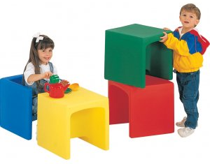 | PRESCHOOL EDUCUBE CHAIR  Available from Hertz Furniture (Item # CFC-007, $154.00 for a set of 4) |  | Versatile cubes can be used as seats, tables, or desks. The Lightweight cubed chair serves three purposes - it's a low chair with a 6"-high seat, but if you flip it over, it becomes a chair with a 9"-high seat. Flip it over again and it becomes a 15" table. Made of non-toxic plastic, no sharp angles or rough edges. Each chair is 15” square and 6 lbs. | 8.2  8.4
4 | 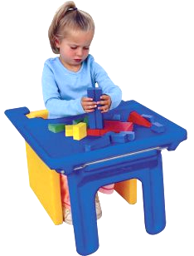 | EDUTRAY FOR PRESCHOOL CUBE CHAIRS  Available from Hertz Furniture, Children’s Factory brand (Item # CFC-1188, $65.00) |  | Get even more use from your chair cubes. When it's time for a snack, just place these plastic trays to the front of a Cube Chair. When you remove the trays the legs fold for flat storage. Spacious 14" x 21" surface. | 8.1  8.3
4 | 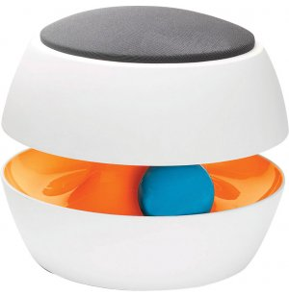 | ONGO KIT CLASSROOM STOOL  Available from Hertz Furniture (Item # 1188 KIT-14, $235.00) |  | A rounded base, firm seat and no backrest promotes balance and coordination early on and helps prevent postural damage. A rubber ball inside supports natural movements. Made of low-maintenance polypropylene with comfy polyester seat cushions. 14” diameter, 12” seat height. Weight is 6 lbs. Maximum weight is 264 lbs. | 4.4  6.4  7.2
4 sets of 4 pieces | 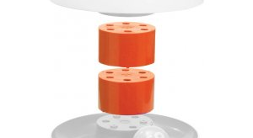 | ADJUSTMENT STACK PIECES FOR ONGO KIT CLASSROOM STOOL  Available from Hertz Furniture (Item # 35501050 KIT-EXT, $26.85 per piece) |  | A height adjustment stack piece allows your KIT Classroom Stool to grow with your students. It can be added to your stool at any time. Each piece adds 3” to the height of the stool. One piece for 15" height, two pieces for 18" height, 3 pieces for 21" height, and 4 pieces for 24" height. Each piece weighs 2 lbs. | 4.4  7.2  6.4
2 | 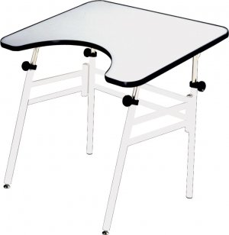 | ADJUSTABLE WHEELCHAIR ACCESSIBLE DRAFTING TABLE (Folding)  Available from Hertz Furniture (Item # RFX-3040F, $349.00) |  | A comfortable, height-adjustable and angle-adjustable worksurface to accommodate wheelchairs. Folds for storage. Angle adjusts from 0 to 45 degrees. Wheelchair inside clearance of 28.5”. 40”x30”, adjustable height from 29” to 44”, weighs 54 lbs. ADA compliant. 18-guage steel legs. Melamine top with cutout for easy accessibility measures 26" x10". A 1/4" raised edge around the desk keeps items from sliding off. | Not in cabinet
2 | 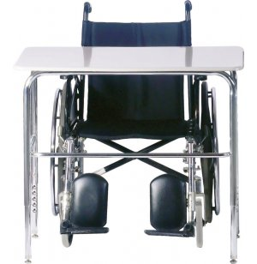 | WHEELCHAIR ACCESSIBLE SCHOOL DESK (Laminate top)  Available from Hertz Furniture (Item # WAD-1800, grey nebula, $134.00) |  | The tubular steel frame of these ADA Compliant Student Desks grants exceptional strength, with U-braces that are double welded to each leg. 18-guage tubular steel frame. The legs are also height-adjustable (26” to 34” height) to comfortably accommodate special-needs students of all ages. With rounded desktop edges, there are no sharp corners. | Not in cabinet

