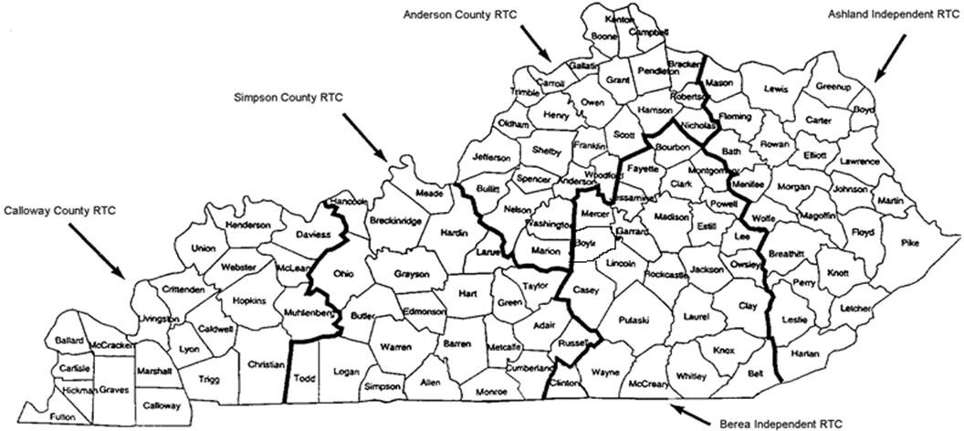
Kentucky Early Childhood Regional Training Centers

Anderson County RTC  210 Saffell Street  Lawrenceburg, KY 40342  (502) 839-2513 Fax: (502) 839-2516  Anderson Co. Regional Training Center Home Page | Alysia Wedding, Director  Penny Nutter, Early Childhood Specialist Julie Goodpaster, Secretary
Ashland Independent RTC  1820 Hickman Street  Ashland, KY 41101  (606) 327-2706 Fax: (606) 327-2796  Ashland Regional Training Center Home Page | Lisa Henson, Director (x 2727)  Kim Roberts, Early Childhood Specialist  Stacey Stevens, Early Childhood Specialist (x 2731)  James Lester, Early Childhood Specialist (x 2734)  Krisi Figley, Secretary (x 2728)  Sherri Kirk, Secretary
Berea Independent RTC  116 Jane Street, PO Box 159  Berea, KY 40403  (859) 986-1929 or 800-343-2959 Fax: (859) 986-9532  Berea Regional Training Center Home Page | Sonia Michael, Director  Jessica Hart, Early Childhood Specialist Andrea Ummel, Secretary
Calloway County RTC  PO Box 1018  Murray, KY 42071  (270) 809-5316 or 5317 Fax: (270) 809-3084  Calloway Regional Training Center Home Page | Nancy Lovett, Director  Chuck Williams, Early Childhood Specialist Britney York, Observation Specialist/Secretary
Simpson County RTC 211 South Main, Suite 1B Franklin, KY 42134  (270) 586- 2008 Fax: (270) 586-2809  Simpson Co. Regional Training Center Home Page | Shelia Baugh, Co-Director April McNaughton, Co-Director  Stacy Raymer, Early Childhood Specialist Melissa Franklin, Secretary

